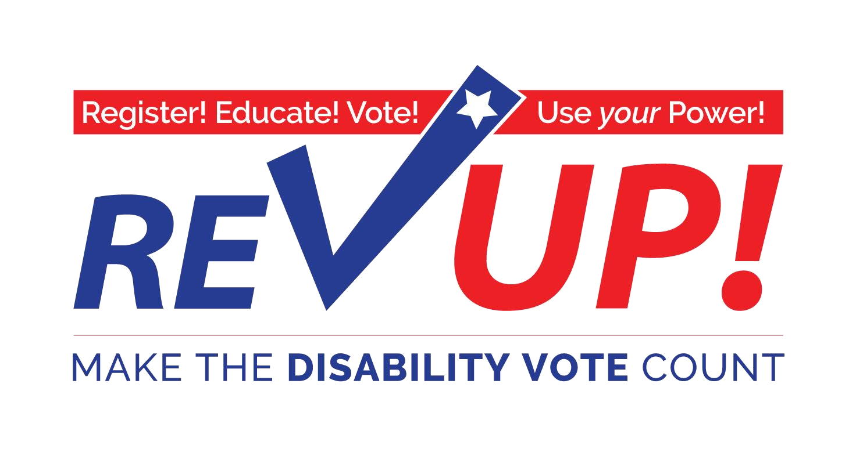

Election Accessibility

TOOLKit

**2018**

# Table of Contents

Introduction 2

Report Regarding the Accessibility of 2016 Election Polling Places 2

Advocating for Election Accessibility 3

Troubleshooting Problems on Election Day 10

Best Practices to Market Voter Hotlines & Other Voter Information 13

Poll Worker Training Resources 14

Best Practices for Interacting with Election Officials 15

Ways to Vote 16

Additional Resources 19

Glossary of Voting Terms 20

Acknowledgements 22

# Introduction

The [REV UP Campaign](https://www.aapd.com/REVUP), launched by the [American Association of People with Disabilities](https://www.aapd.com) (AAPD) in 2016, is a nonpartisan initiative that coordinates with national, state, and local disability organizations to increase the political power of the disability community while also engaging candidates and the media on disability issues. The Campaign focuses on voter registration, education, access, and engagement. REV UP stands for *Register!* *Educate!* *Vote!* *Use* your *Power!*

People with disabilities accounted for over 35 million eligible voters in 2016 (that number jumps to over 62 million eligible voters when you count family members in the same household) according to [Rutgers University](http://smlr.rutgers.edu/news/projecting-number-eligible-voters-disabilities-november-2016-elections-research-report). The disability community has incredible potential to demonstrate that the power of the disability vote has the potential to ensure that all candidates and elected officials address issues that are important to people with disabilities by increasing the political participation of people with disabilities. Rutgers University also found that, in 2012, 30% of people with disabilities reported difficulty in voting compared to 8% of people without disabilities.

This Election Accessibility Toolkit is meant as a tool to assist disability advocacy organizations and individual advocates when working with voters and election officials. It also includes information on troubleshooting problems encountered on Election Day, reporting barriers, and additional resources.

## Report Regarding the Accessibility of 2016 Election Polling Places

The REV UP Campaign Election Accessibility Subcommittee authored a White Paper to report on the overall accessibility of the 2016 election. This report draws on data gathered from other studies about the barriers (physical and otherwise) that people with disabilities encountered while pursuing their civil right to vote. This document is intended to help advocates and election officials consider the barriers that may exist within their local electoral system. The white paper concludes with recommendations to the Federal Government and to States to improve accessibility in subsequent elections.

**Download the Report Regarding the Accessibility of 2016 Election Polling Places**

* [PDF](http://bit.ly/2sW64hy)
* [Microsoft Word](http://bit.ly/2JAmSSg)

# Advocating for Election Accessibility

Disability advocates and organizations can take on several different roles or activities as it relates to voting and accessibility.

## Conducting polling place accessibility surveys and advocating for solutions to identified barriers:

* [ADA Checklist for Polling Places](https://www.ada.gov/votingchecklist.htm) – ADA.gov

### Conducting the survey

* [Polling Place Accessibility Survey](https://www.ada.gov/votingchecklist.htm#toc17) – ADA.gov
* Individuals using the 2016 Checklist do not have to be experienced in evaluating facilities for accessibility. It is designed to be used to evaluate key areas that must be accessible. An evaluation of polling place accessibility focuses on those areas of a facility that may be used as a polling place on Election Day. Think about how people generally arrive, enter, and move through the polling place. Parking, sidewalks and walkways, entrances, hallways, and the voting space are all places where voters with disabilities encounters issues.

### Solutions to Five Commons Barriers:

1. **Parking**: Many polling places provide parking for voters, but the provision of accessible parking is often overlooked. Parking areas may lack accessible parking spaces with adequate access aisles and signs, or may be on a sloped surface. The ADA requires the access aisle to be at least 60 inches wide for cars and 96 inches wide for vans. Van spaces can also have an access aisle at least 60 inches if the width of the van parking space is at least 132 inches. A sign, with the International Symbol of Accessibility, must mark each accessible parking space. Van-accessible spaces must be designated as such on the sign at these spaces. If only one accessible space is provided, it must be a van-accessible space.
   * Temporary Solution: Temporary parking must be located on the most level area available and as close to the accessible entrance as possible. Traffic cones and portable signs can be used to create accessible parking spaces and access aisles.
2. **Sidewalks and walkways**: If sidewalks and walkways are in disrepair, it can be difficult, and sometimes impossible, for a voter using a wheelchair or other mobility device to safely navigate to the polling place. Often, sidewalks and walkways are uneven, cracked, or contain potholes, gravel, dirt, or grass. Some sidewalks do not include curb ramps or, if they do, the ramped section is too narrow or steep. Under the ADA, sidewalk or walkway surfaces must be at least 36 inches wide, without abrupt level changes (no level change greater than ½ inch), and the surface must be stable, firm, and slip resistant. Curb ramps should not be too steep (no steeper than 1:12).
   * Temporary Solution: Temporary plates (no more than ½ inch thick) can be used to cover holes or cracks to provide a more level walkway. Ramps at least 36 inches wide, with a slope no more than 1:12, may be used to provide temporary access over curbs or onto sidewalks.
3. **Entrances**: The entrance area must be level (no level change greater than ½ inch) and should not slope steeply in any one direction. All door openings must provide a minimum width of 32 inches and include 18 inches of clear space beyond the latch side of the door. Additionally, the door hardware must not require tight grasping, pinching, or twisting, and the height of the door threshold must not be greater than ½ inch.
   * Temporary Solution: The use of temporary ramps can provide access over steps or high thresholds. If the area in front of the door is not level or does not provide adequate maneuvering space, then the door may be propped open to allow the person using a wheelchair to enter the polling place. If one door of a double-leaf door is not wide enough, propping open the second door may provide enough clearance. Alternatively, a temporary doorbell or buzzer system may be used to alert a poll worker to open the door for the voter.
4. **Hallways**: In many polling places, particularly those in large facilities such as schools and apartment buildings, hallways contain drinking fountains, coat racks, fire extinguishers, and other protruding objects. These objects may pose hazards to voters with vision disabilities, who may bump into them if they are not detectable by a sweep of a cane. The ADA requires that wall-mounted objects located between 27 inches and 80 inches above the floor may not protrude from the wall more than 4 inches.
   * Temporary Solution: Place traffic cones or other cane-detectable barriers, such as planters or portable railings, at or under protruding objects. Cane-detectable barriers can also be placed to re-direct voters with vision disabilities around or away from the protruding object. An alternate pedestrian route that does not include the protruding object, if available, may be appropriate.
5. **Voting area**: Voting often occurs in a small room or area within a building, with little space at the check-in tables and voting machines, making it difficult for voters with mobility disabilities to move through the voting area and cast their ballots. In winter months or during the rainy season, election officials may use cardboard, plastic floor coverings, tarps, or mats to cover the floor. These coverings can make it difficult to navigate and can easily become trip hazards for voters with disabilities and others. Under the ADA, there must be a minimum 36-inch wide route in and through the voting area. There also must be enough clear floor space in at least one voting station or booth to allow a voter using a wheelchair or other mobility device to approach, maneuver, and leave the voting station. Floor surfaces must be stable, firm, and slip resistant.
   * Temporary Solution: Arrange check-in tables and voting stations to provide an accessible path for the voter to go from the check-in table to the voting station and out again. At least one voting station should provide at least 30 x 48 inches of clear floor space to allow a voter using a wheelchair or other mobility device to maneuver. All floor coverings, such as cardboard or plastic sheets, should be removed or firmly affixed to the floor to provide a stable and slip-resistant floor.

## Offering poll worker training and advocating for poll worker training around voters with disabilities be mandatory for election officials:

* Example from the Wisconsin Elections Commission – [Accessible Voting Training Tutorial Video: This is Where We Vote](http://elections.wi.gov/publications/videos/accessibility-training-this-is-where-we-vote)
* The number of poll workers to train in any state is an enormous task. Consider partnering with other disability advocacy groups like SABE and People First or voting rights groups like League of Women Voters or Rock the Vote. In training poll workers, emphasis should be placed on several issues:
  + **Poll workers should recognize when and how to assist voters with disabilities.** Poll workers should understand that all voters have the right to vote privately and independently. It is not up to a poll worker to determine a person’s qualification to register or to vote. Poll workers should be trained to provide the utmost respectful and courteous level of service to every voter. Voters with disabilities, like every other voter, must be afforded the ability to cast their ballots in private.
  + **Poll workers should be sensitive to the rights and identities of voters with disabilities.** Poll workers should be trained on disability sensitivity – the ability to recognize and respond to the needs and sensitivities of people with different types of disabilities. Poll workers should be taught disability sensitivity for working with voters with disabilities and, in particular, focus on not treating voters with disabilities as less capable voters.
  + Poll workers should do the following when working with voters with disabilities:
    - **Use common sense**. People with disabilities want to be treated the same way everyone else is treated.
    - **Avoid patronizing words or actions**. Show the person the same courtesy and respect that you expect to receive from others. Treat adults as adults. Be considerate and patient.
    - **Ask a voter what you can do to assist**. Do not help without asking or assume you know what is needed. Be patient if the voter requires more time to accomplish various tasks.
    - **Communicate with the voter**. Remember that some people with disabilities may have an assistant, interpreter, or companion with them. It is important to always look and speak directly to the voter rather than to their companion, interpreter, or assistant. Face the voter with a disability when you are talking to them.
* **Access**: Poll workers must be instructed on how to ensure voters with disabilities can get into and maneuver inside the polling place. This includes providing poll workers with the mitigating measures that were identified when the polling place was evaluated for disability access. Poll workers need to be provided with the necessary and proper equipment, signs, etc., to ensure the polling place is accessible.
* **Curbside Voting**: If a polling place is not fully accessible, and cannot be made accessible on Election Day, poll workers must be familiar with the procedures for conducting curbside voting. Procedures for curbside voting include taking the voter index, ballot marking pen, and ballot (in a secrecy sleeve) outside to the voter; removing the receipt stub before giving the ballot and stub to the voter; and allowing the voter to mark the ballot in private. Instead of a paper ballot, some states bring a voting machine out to the voter’s car.
* **Voting System Access**: Poll workers must remember that some voters with disabilities may have disabilities that are not visible. When a voter wants to vote on the accessible voting machine, poll workers must allow them to use it. Poll workers should not question why the voter needs to use the accessible voting machine or assume the person does not have a disability. Each polling place must have at least one accessible voting machine. Poll workers should ensure voting machines are set up in an accessible manner and, if a machine has auxiliary aids that provide or improve access, they should be familiar with the proper set-up and use (e.g., magnifying glasses, alternate language selection, audio headsets, and tactile controls). Poll workers should be trained on how a voting machine can be modified, moved, or set up to accommodate individual disability-related access needs. For example, poll workers should be trained to adjust the height and angle of the touch screen to match the most effective range and reach of voters with limited manual dexterity.
* Remind election officials voters with disabilities constitute a large number of eligible voters in the county. Studies show that people with disabilities vote at lower levels, register to vote at lower levels, and expect difficulties at their polling place at higher levels than those who do not have a disability. Building relationships with groups that touch this population and working to ensure that any barriers are identified and addressed could go a long way in closing this gap. Every state has a [Center for Independent Living](http://www.ilru.org/projects/cil-net/cil-center-and-association-directory) (CIL) and [Protection and Advocacy organization](http://ndrn.org/en/ndrn-member-agencies.html). These organizations can offer valuable insight and assistance regarding accessible voting.
* Additional resources and training materials for poll workers are available later in this Toolkit.

## Recruit individuals with disabilities as poll workers:

* Election officials might consider recruiting individuals with disabilities to be poll workers. For some voters, the presence of a poll worker with a disability can make the voting experience more comfortable and might increase the likelihood that they will be receptive to offers of assistance. Disability organizations are great places to look for potential poll workers with disabilities.
* Election officials may consider the following practices to improve conditions for poll workers with disabilities:
  + Split shifts—Some poll workers with disabilities would benefit from having the option to reduce their time at the polls to a shift with more manageable hours.
  + Environmental sensitivities—Some poll workers may be sensitive to substances, such as perfumes and air fresheners.
  + Simple adaptive technologies—Some poll workers may benefit from assistive technologies, soft-grip tools and magnifying strips, to perform their duties. To improve the accessibility of future elections, officials might ask poll workers to complete a questionnaire to determine additional needs at the polling place. The responses to the questionnaire may provide ideas and solutions for addressing accessibility needs on the next Election Day.

## Arrange meetings between state/local election officials and the disability community to share stories about problems encountered while trying to vote.

* Arrange to meet with local representatives with other organizations also promoting voting rights. League of Women Voters, ACLU and NAACP are useful partners. Other state and local disability organizations – such as a [center for independent living](http://www.ilru.org/projects/cil-net/cil-center-and-association-directory), your state [protection and advocacy agency](http://ndrn.org/en/ndrn-member-agencies.html), [state Council on Developmental Disabilities](https://nacdd.org/councils/), a [local chapter of The Arc](https://www.thearc.org/find-a-chapter), or a [local Paralyzed Veterans of America chapter](https://www.pva.org/national-service-offices/find-nso-offices/%7Bsearchstate%7D) – should also be invited.
* Ask election officials to develop an outreach plan to raise awareness among voters with disabilities about accessible polling places and accessible election programs in the jurisdiction. The outreach might address the following issues:
* Voter registration
* Using the accessible voting system
* Requesting accommodations to vote as well as when receiving information about the election
* Where to submit complaints if voters experience a problem
* Process of filing a HAVA complaint
* Voter rights under the Help America Vote Act (HAVA), Voting Rights Act (VRA), and other applicable voting laws

## Conduct testing of accessible voting machines

* Prior to each election, all electronic tabulating equipment must be tested to verify that 1) the equipment is performing properly, 2) the ballots have been properly prepared for each precinct, and 3) that the programs will accurately count votes. It is the responsibility of the election commission to conduct a preliminary and public accuracy test where a "test deck" of voted ballots is tabulated by the electronic equipment and the results are verified against predetermined results.
* It is recommended that the chart of predetermined results be prepared as early as possible prior to the election. The following information will be needed to complete this task:
  + A complete listing of all offices that will appear on the ballot
  + The total number of candidates whose names will appear under each office
  + The total number of votes allowed under each office and
  + The total number of proposals that will appear on the ballot. Preparing the chart of predetermined results as early as possible will help to ensure that the required tests and any needed repairs to voting equipment or corrections to ballots or programs may be carried out in a timely manner.

## Organize trainings or workshops to ensure the disability community is educated about their right to vote and the accommodations they have the right to access (including the right to vote of people under guardianship).

* Host trainings on voting rights with public entities like libraries with practice using voting assistance machines and casting practice ballots. Your [state protection and advocacy agency](http://ndrn.org/en/ndrn-member-agencies.html) can be a great partner on a voter rights training.
  + Example: North Dakota Protection & Advocacy (NDPA) collaborated with public libraries throughout the state to host voting education days which featured a display of HAVA materials, including brochures, fact sheets, and DVDs. An AutoMARK voting machine was available at each library to offer citizens the opportunity to learn to use the assistive voting device prior to Election Day. NDPA and the North Dakota Secretary of State (NDSOS) worked collaboratively to increase awareness of voting rights and voting information for people with disabilities. A bookmark was developed specifically for use in libraries throughout North Dakota during the election season.
* Create voter education kits prior to elections. The kits should include information on voter registration, polling place locations, election dates and deadlines, frequently asked questions, resources for more information, etc.
  + Example: West Virginia Advocates provided voter education kits to numerous individuals at conferences, provider locations, psychiatric hospitals, nursing homes, and senior centers. The kits included outreach information, voter registration forms, absentee ballots, polling site information, hotline numbers and frequently asked questions. The voter education kits served as a catalyst for the five percent increase of voters with a full range of disabilities participating in the state and local election process
* Host outreach events for individuals with disabilities to share their voting needs and concerns.
  + Example: Disability Rights Mississippi (DRM) initiated a four-month "A Time to Share" listening tour across the state as an outreach and input campaign with a mission to hear from as many Mississippians with disabilities, family members, and services providers as possible regarding voting needs and accessibility concerns. A total of 41 outreach opportunities and events in 28 different communities were held across the state in order to conduct outreach and receive input from participants. The "A Time to Share" listening tour resulted in increased connections and making services more readily available to underserved and unserved demographic groups, while providing an opportunity to educate families, community partners, and other advocates about voting rights for upcoming elections.

## Advocate for the accessibility of voter information and outreach materials (including websites, sample ballots, etc.)

* Election information can be complex. Voters must learn about the elections process and plan how they will vote while also reviewing details about the races, candidates, and ballot questions. Pre-election day voting practice can greatly alleviate anxiety and questions about the voting process to make voting an enjoyable experience. This practice can be especially beneficial for voters with cognitive disabilities that affect their ability to read, interpret, or remember written information.
* Research on designing voter information for people with neurocognitive disabilities, including aphasia, Alzheimer’s disease, and traumatic brain injury, showed that clear, consistent writing and design is critical, just as it is for people with low literacy.
* Content should be made accessible and available in plain language for voters with cognitive and reading disabilities prior to Election Day. Possible strategies include:
  + Help voters prepare by providing a sample ballot that is an accurate version of the Election Day ballot, so voters can practice with it.
  + Allow users to annotate content and store notes between sessions so they can remember and track their progress.
  + Support social reading by allowing voters to discuss what they read with others or seek help with the information.
* Design websites that present voting information that is accessible by:
  + Presenting content using multiple formats, such as combining printed text, images, and audio.
  + Presenting content using multiple phrasings, for example, presenting several synonyms for a word, or presenting both the positive and negative form of a statement.
  + Including text-to-speech options for voters who prefer (or need) to listen to information rather than read it.
  + Summarizing key messages to reduce the amount of text and simplify complex passages.
  + Keeping the navigation and design simple so it does not distract from the information.
  + Including a progress bar to show overall progress and identify gaps in non-linear reading.
* [Creating an Accessible Political Campaign: Practical Tips to Include People with Disabilities and Win More Votes!](http://advocacyla.org/images/publications/Voting/AccessibleCampaign.pdf)

This resource from the Advocacy Center in Louisiana provides helpful advice on making political campaigns more accessible to individuals with disabilities.

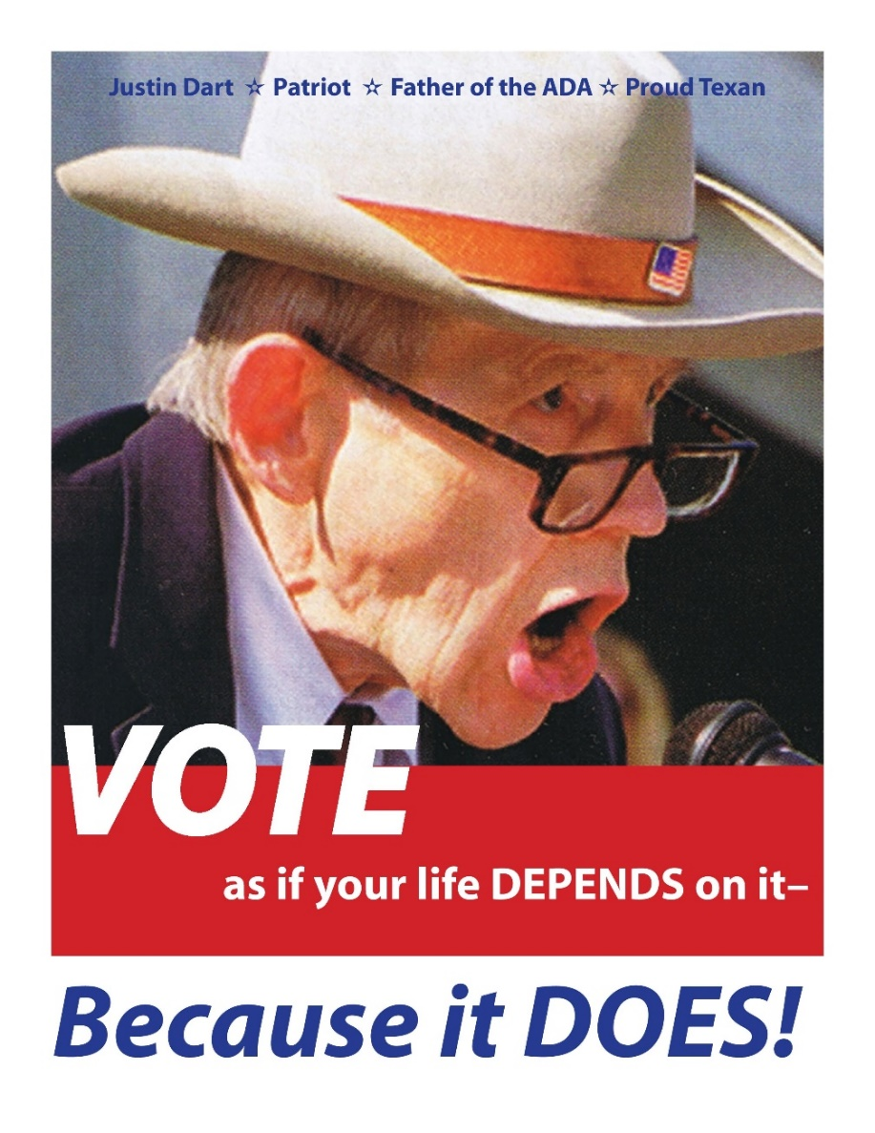

*Photo of Justin Dart with text: "VOTE as if your life depends on it - Because it DOES!*

# Troubleshooting Problems on Election Day

Despite legislation like the Americans with Disabilities Act (ADA) and the Help America Vote Act (HAVA) that mandate accessibility of public accommodations and the voting process, many voters with disabilities still encounter barriers to casting a private and independent ballot. Research on [Disability, Voter Turnout, and Voting Difficulties in the 2012 Elections](http://smlr.rutgers.edu/sites/default/files/images/Disability%20and%20voting%20survey%20report%20for%202012%20elections.pdf) from the Research Alliance for Accessible Voting found that **almost one-third (30.1%) of voters with disabilities reported difficulty in voting at a polling place in 2012, compared to 8.4% of voters without disabilities.**

## Requesting Assistance on Election Day

### Election Protection

Visit [www.866ourvote.org](http://www.866ourvote.org/) or call 1-866-OUR-VOTE (1-866-687-8683) if you have any issues or concerns related to Election Day.

* Call 888-Ve-Y-Vota (888-839-8682) for bilingual English and Spanish assistance
* Call 888-API-VOTE (888-274-8683) for assistance in English, Chinese, Vietnamese, Korean, Bengali, Urdu, Hindi, or Tagalog
* Call #YallaVote (844-418-1682) for bilingual English and Arabic assistance

### State Protection & Advocacy Agencies

There is a Protection & Advocacy Agency in every state and territory. Each organization has a Protection and Advocacy for Voting Access (PAVA) project that responds to the unique needs of voters with disabilities in the state/territory.

* The REV UP Campaign lists these hotline phone numbers on our [State Resources and Events web page](https://www.aapd.com/advocacy/voting/state-resources-and-events/)
* You can also go directly to your [state protection and advocacy agency website](http://ndrn.org/en/ndrn-member-agencies.html)

### Voter Support Service

The Arc of the United States offers a [Voter Support Service](https://vote.thearc.org/) mobile website for people with disabilities to find their polling place and report accessibility barriers.

### State Voter Hotlines

Many state Election Offices or Secretary of State Offices operate their own voter assistance hotlines.

* [Find My State or Local Election Office Website](https://www.usa.gov/election-office)

## Importance of Reporting Voting Barriers

It is important to report all barriers to voting experienced, even if you are able to resolve the barrier and cast your ballot. Reporting these barriers to any of the entities listed above allows disability and voting advocates to gather accurate data on the barriers to voting that still exist for people with disabilities. This information is useful when advocating for changes and improvements to the voting process.

## Training Videos to Respond to Possible Problems at the Polling Place

These short training videos from the Self Advocates Becoming Empowered (SABE) GoVOTER Project outline how voters with disabilities can respond to potential barriers encountered at a polling place.

* [Rude poll worker](http://www.sabeusa.org/govoter/voting-info/voting-stories-and-video/barriers-video-rude-pollworker/) (1min 45sec)
* [You’re in the voting booth and you don’t know what to do](http://www.sabeusa.org/govoter/voting-info/voting-stories-and-video/barriers-video-youre-in-the-voting-booth-and-you-dont-know-what-to-do/) (1min 32sec)
* [You don’t know how to get information](http://www.sabeusa.org/govoter/voting-info/voting-stories-and-video/barriers-video-you-dont-know-how-to-get-information-about-voting/) (2min 59sec)
* [The poll worker says you can’t vote](http://www.sabeusa.org/govoter/voting-info/voting-stories-and-video/barriers-video-the-pollworker-says-that-you-cant-vote/) (2min 11sec)
* [The poll worker asks for your guardian](http://www.sabeusa.org/govoter/voting-info/voting-stories-and-video/barriers-videothe-pollworker-asks-for-your-guardian/) (1min 35sec)

## Prepare in Advance of Election Day

If you are concerned about potential barriers at your polling place, you can make some inquiries in advance of Election Day.

### Contacting your Elections Office

It may be useful to contact your state, county, or local Elections Office in advance of the election to check the accessibility of your polling place, ask about accessible voting machines and curbside voting, or inquire about poll worker training regarding voters with disabilities.

* [Find My State or Local Election Office Website](https://www.usa.gov/election-office)

### Voter ID Requirements

Some states have strict voter identification (ID) requirements in order to vote. Make sure you are prepared with the proper ID well in advance of Election Day.

* **VoteRiders**

VoteRiders offers wallet-sized [Voter ID Info Cards](http://www.voteriders.org/voter-id-info-cards) (in English and Spanish) for all 50 states and the District of Columbia. Each card provides a breakdown of the voter ID requirements in that specific state. They also host a Voter ID Hotline: 1-844-338-8743.

* **Spread The Vote**

[Spread The Vote](https://www.spreadthevote.org/) provides direct assistance to help voters obtain the proper identification to vote in their state. They are currently active in Florida, Georgia, Tennessee, Texas, and Virginia.

### Getting to the Polls

* **Carpool Vote**

Carpool Vote is a[national platform that connects volunteer drivers with anybody needing a ride to cast their vote](http://carpoolvote.com/). The platform is accessible to voters with disabilities and offers rides in accessible vehicles as long as there are volunteer drivers with accessible vehicles.

* **Contact State and Local Political Parties**

State and local political parties often help organize rides to get their voters to the polls on Election Day.

* **Plan your route to the polls using public transportation**

## Provisional Balloting

*From* [*Election Protection*](https://www.866ourvote.org/issues/provisional-balloting)*:*

“A voter has the right to cast a provisional ballot if he or she believes they are eligible and registered to vote but is unable to cast a regular ballot, due to reasons such as the voter’s name not appearing on the registration list at the polling place, the voter does not have a required form of voter identification, or an election official challenges the voter’s eligibility. After a voter has cast a provisional ballot, election officials determine whether or not to count the provisional ballot by verifying the voter’s eligibility. Sometimes states require voters to take additional steps to verify their eligibility in order for the provisional ballot to count, such as submitting an acceptable form of identification at a board of elections office within a specified time period after Election Day.”

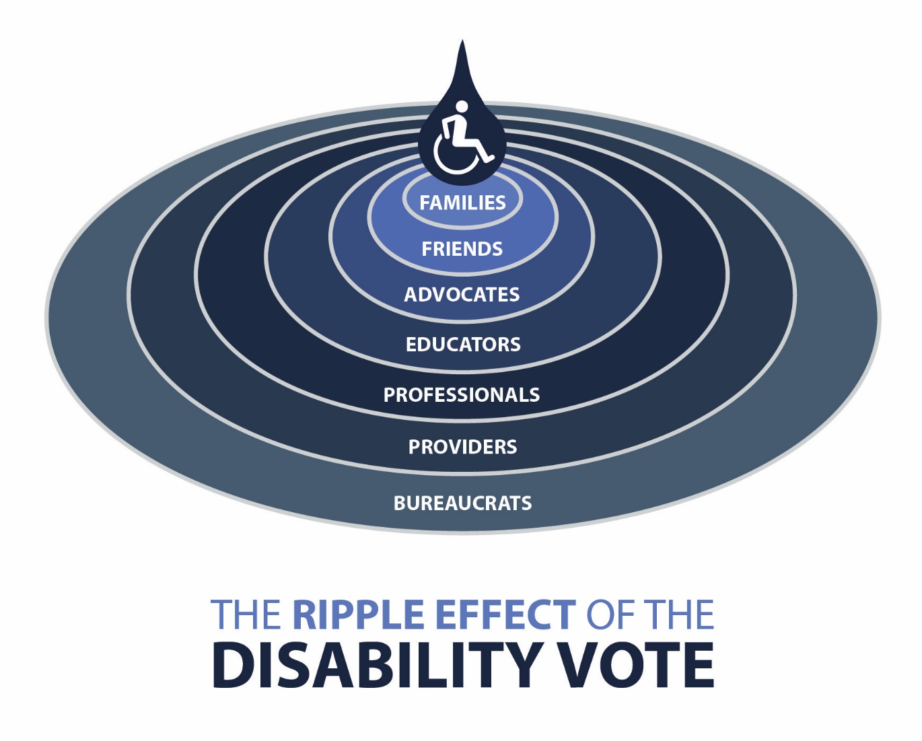

*The Ripple Effect of the Disability Vote – A raindrop ripples outward in concentric circles with the icon of a disabled person in the middle. The words Families, Friends, Advocates, Educators, Professionals, Providers, Bureaucrats fill each ripple going from the center to the outside ring.*

# Best Practices to Market Voter Hotlines & Other Voter Information

## Know Your Audience

* What is the age of your intended audience?
* What is the geographic location of your audience?
* What language(s) does your intended audience speak?
* What is the literacy level of your intended audience?
* What are the media preferences of your intended audience?

## Develop Your Message

* Make your message clear, short, and easy to read
  + Brainstorm message with colleagues
* Promote your organization and logo whenever possible
* Hotline
  + Position the hotline number to be clearly visible
  + Explain the exact purpose of your hotline so callers will not have unrealistic expectations

## Promote, promote, promote

*Voter registration/education events and disseminating important voter information will have a greater impact if you publicize events and information multiple times, well in advance of any deadlines.*

* Social Media – Twitter, Facebook
  + Create an event on Facebook
  + Ask your followers and partner organizations to share the event
* Website –Post on your home page if possible
* Local Media – Ask newspapers or radio stations to cover your voting event
* Send email to friends, colleagues, and family – encourage them to share the event with their network
* Create flyers and post them around town

# Poll Worker Training Resources

Poll workers play an important role in ensuring all eligible voters can participate in an election. However, some poll workers may not be familiar with the disability community and the accommodations some voters with disabilities need in order to cast a ballot privately and independently.

Research on [Disability, Voter Turnout, and Voting Difficulties in the 2012 Elections](http://smlr.rutgers.edu/sites/default/files/images/Disability%20and%20voting%20survey%20report%20for%202012%20elections.pdf) from the Research Alliance for Accessible Voting found among voters with disabilities from the 2012 election who found the overall voting process to be difficult, **8.1% of survey respondents identified a difficulty communicating with poll workers or other officials at the polling place**.

[ADA Checklist for Polling Places](https://www.ada.gov/votingck.htm)

This document from the US Department of Justice is a technical assistance publication on polling place accessibility for voters with disabilities.

[Accessibility Education Series for Poll Workers](https://www.youtube.com/playlist?list=PLRLyLM3etLRm6ciKMKXDY6y5ECjIHyUVM)

This YouTube video series from Indiana Disability Rights covers how to make polling places accessible and how to assist voters with disabilities. Videos are available in English, Spanish, and American Sign Language (ASL).

[Making Elections Accessible](https://youtu.be/LJxGGVAbnk8)

This YouTube video from the Kentucky Secretary of State serves as a useful training tool for election officials.

[Voting Accessibility in SC](https://vimeo.com/158440380/6f470dc4f5)

This Vimeo video from the Protection and Advocacy for People with Disabilities, Inc. (P&A) in South Carolina identifies different ways to vote as well as common accessibility barriers people with disabilities experience while voting.

[Poll Worker Guide: Polling Place Accessibility](https://www.pandasc.org/wp-content/uploads/2016/07/Pollworker-Pocketguide-on-Accessibility.pdf)

This PDF pocket guide from the Protection and Advocacy for People with Disabilities, Inc. (P&A) in South Carolina provides a quick reference of things to remember to ensure polling sites are accessible.

[Tips for Serving Voters with Disabilities](https://www.pandasc.org/wp-content/uploads/2016/07/Tips-for-Serving-Voters-with-Disabilities.pdf)

This one page PDF from the Protection and Advocacy for People with Disabilities, Inc. (P&A) in South Carolina provides useful tips for interacting with voters with disabilities.

[Helping Tennessee Vote – A poll worker’s guide to assisting voters with disabilities](https://www.disabilityrightstn.org/documents/helping-tn-vote-drtn-2015-web.pdf)

This PDF guide from Disability Rights Tennessee provides guidance on poll site accessibility, helping voters with disabilities, providing accommodations for voters with disabilities, and other resources.

# Best Practices for Interacting with Election Officials

1. Election laws are different in each State. Make sure you understand the State and Federal Laws your Election Officials must follow before reaching out to them.

*[Electionary provides an* [*online guide to state election laws*](http://www.electionary.info/en/ogea/) *in the US.]*

1. Take time to learn the different roles of State versus County election officials.

*[The* [*National Conference of State Legislatures*](http://www.ncsl.org/research/elections-and-campaigns/election-administration-at-state-and-local-levels.aspx) *provides additional information on state and local roles.]*

1. County election offices often have very little staff, who are spread very thin on Election Day. If you are looking to collaborate, try reaching out to them during the months they are not holding an election.
2. Invite your local election officials to come speak to members of your community about the challenges they have serving voters with disabilities.
3. Offer to help teach local election officials about disability rights, how to serve voters with disabilities, and accessibility.

*[Poll worker / election official training videos and resources are included later in this Toolkit]*

1. In many states, there are associations for election officials. These groups are often looking to offer education to their members on a variety of topics, allowing you to reach more people at one time.

*[The* [*Election Center*](https://www.electioncenter.org/index.html) *is a national membership organization for government officials who serve in voter registration and elections administration.]*

1. Let local election officials know what kind of work you are doing in their community and offer to collaborate.
2. Prepare helpful handouts that election officials can use when serving voters with disabilities.

# Ways to Vote

Over the course of history Americans have used many different methods to vote, beginning with a show of hands or voices at communal meetings to hand bills, mechanical lever machines, paper ballots, electronic machines and even on-line systems. Basic voting rights are set and monitored by the Federal Government, election policy is established by the State Governments, and elections are administered by County authorities. This means that the bulk of decision-making about election processes and how voters will vote are made by local elections officials, with options set by the state legislatures and parameters established by Congress and the courts.

Currently, [most counties across the nation offer multiple ways to vote](https://ballotpedia.org/Voting_methods_and_equipment_by_state), including some with accommodations for people with disabilities.

## Paper Ballot

The most common form of voting is casting a **paper ballot**, which itself can take on different forms. An optical scan paper ballot is very popular, these have a fillable bubble by the candidate or initiative position, the voter fills in the bubble with a pen to make their choice. Later these ballots are scanned to be counted electronically.

Some jurisdictions use a paper ballot asking the voter to draw a line or arrow connecting the office to the candidate choice or position to the initiative. This type is used often for rank choice voting, a system that allows the voter to make a second and third or more choices in case no one candidate reaches 50% plus one vote to win and avoid a run-off election.

A third type employs a paper card and a small clipboard device. A voter punches holes in the card to mark his or her vote. The pattern of holes in the card indicates the votes cast. The ballot may then be placed in a box to be tabulated manually or scanned by a computer.

Finally, some smaller jurisdictions still use a filled in paper ballot that is hand counted at the polling place, and others use a paper ballot for [provisional voting](https://en.wikipedia.org/wiki/Provisional_ballot). While paper ballots are used most frequently, they are not accessible to all voters, especially those who experience barriers to seeing, using theirs hands and arms, or reading and comprehending.

## Curbside Voting

**Curbside voting** is an option for voters who experience barriers to access entering the polling place or who need to remain in their automobile. When using this option, a poll worker brings a paper ballot on a tray to the voter in an automobile parked *curbside* near the entrance to the polling place. Polling places are required to have a bell or notification system near the curb to alert the poll workers to the presence of a *curbside voter*.

While this form of voting has been used as an accessibility option for decades, it is often unpopular among voters with disabilities because of the lack of privacy.

## Voting by Mail

**Voting by mail** through casting an absentee ballot is quickly becoming a primary choice of voting for many Americans. These ballots are mailed to the voter in advance of the election and the voter is responsible for mailing them back or dropping them off at their polling place or county elections office in time to be counted. In nearly all jurisdictions nationwide the absentee or mail ballot must be requested in advance. Contact your county elections office or consult their website for the deadline to request this type of ballot before each election.

Some states allow “no excuse” absentee voting, where any voter can request an absentee ballot, while others require a valid reason for why a voter cannot vote in-person. Additionally, some states allow voters to become a *permanent absentee voter* when they register to vote. This form of voting is an accessible option for disabled voters who encounter transportation barriers, but because it engages a paper ballot, it is not accessible to all voters with disabilities, as noted above.

## Accessible Electronic Voting Machine or Ballot Marking Device

Every polling place is required by federal law to have an **accessible electronic voting machine or** [**ballot marking device**](https://en.wikipedia.org/w/index.php?title=Ballot_marking_device&oldid=825644627). Some use a paper ballot that is inserted into and filled out by the machine. Others, like a Direct Recording Electronic System (DRE), communicate the voter’s choice(s) electronically. There are many different types of these machines used in different states, and there are frequently differences between counties within a state. These machines allow a voter to cast a ballot privately and independently using a variety of functions. For example, a blind person can use it through listening and voice commands, or someone with dexterity issues can use paddles or *sip and puff* to navigate the ballot process. In addition, people with processing disorders are able to use multiple senses like sight and hearing to comprehend the ballot and select their choices. [Learn more about voting methods and equipment in each state](https://ballotpedia.org/Voting_methods_and_equipment_by_state).

Many people with disabilities find these machines very accessible for eliminating barriers to voting. They are mostly used in polling places that require the voter to travel, but some counties will deliver the machine to a disabled voter’s home by request, prior to Election Day.

## Remote Ballot Marking and Accessible Vote By Mail

Remote ballot marking systems are systems for voters to mark their ballots outside of a voting center or polling place. These systems, also called accessible vote by mail, allow a voter to download a blank ballot to mark electronically, print, and then cast by returning a printed ballot summary to the elections office by mail. During the process of voting, no voter information or ballot data is ever transmitted back to a state or county server. It is NOT internet voting.

### States that provide accessible remote ballot marking include:

**California:** Starting June 2018, as part of implementing the Voters Choice Act (SB450), the counties of Madera, Napa, Nevada, Sacramento, San Mateo are providing voters with disabilities access to accessible ballots.[1]

**Hawaii:** Starting with the August 2018 Primary, voters with a disability can login to the voter registration system and, during and active election, download their ballot. The HTML ballots can be marked on the voter’s own PC, Mac, iPad, etc. They print a summary page and mail that back to the county.

**Maryland:** Implemented a remote ballot marking system a few years ago. Anyone can become an absentee voter (no excuse) and can request a link to their ballot, which will be emailed to them. The voter marks their ballot and prints a marked ballot locally to be mailed in.

**New Mexico:** Just adapted the Maryland system. Refer to the Secretary of State’s website for details on when it’s available. <http://www.sos.state.nm.us/Voter_Information/Voters_with_Disabilities.aspx>

**Ohio:** All 88 counties are under a court order to implement a remote accessible process by the November election. A voter desiring to vote on their own equipment is required to fill out a special absentee form and supply an email address so the ballot can be emailed to them. More details will be available on the Secretary of State website:<https://www.sos.state.oh.us/elections/voters/voters-with-disabilities/>

**Oregon:** As a “vote-by-mail” state, all registered voters receive a ballot and return envelope in the mail prior to an election. Voters with a disability can login to the voter requisition system and, during and active election, download their ballot. The HTML ballots can be marked on the voter’s own PC, Mac, iPad, etc. They print a summary page and mail that back to the county. More information and a sample ballot can be found at: <http://sos.oregon.gov/voting/Pages/disabilities.aspx>.

A good example of how voters with a disability can vote at home is shown in this video by Rooted in Rights.

* [Remote Accessible Voting](https://vimeo.com/235385563) – Disability Rights Oregon

Options for accessible voting are getting better for people with disabilities as technology improves. However, much more work is left to be done. We need to advocate in every state for systems like remote ballot marking or accessible vote by mail to ensure true equality. Please see the advocacy section of this tool kit for more ideas and information about getting active in your state and advocating for election equality!

# Additional Resources

## REV UP Resources

* [Voter Resources Center](https://www.aapd.com/advocacy/voting/voter-resource-center/)
* [State Resources and Events](https://www.aapd.com/advocacy/voting/state-resources-and-events/)
* [Voting Statistics](https://www.aapd.com/advocacy/voting/statistics/)
* [Logos and Graphics](https://www.aapd.com/advocacy/voting/rev-up-images-and-toolkits/)
* [National Disability Voter Registration Week Toolkit](http://bit.ly/2IU8ALJ)
* [National Disability Voter Registration Week Social Media Toolkit](http://bit.ly/2IRT6rp)
* [Candidate Questionnaire Template](http://bit.ly/2IRp8ny)
* [Candidate Forum Guide](http://bit.ly/2vjhuAz)
* Issues Guide *(Coming soon! Check* [*www.aapd.com/REVUP*](http://www.aapd.com/REVUP) *for updates)*

## Voting Rights Resources

* [VOTE. It’s Your Right – A Guide to the Voting Rights of People with Mental Disabilities](http://www.bazelon.org/wp-content/uploads/2017/01/voting-rights-guide-2016.pdf)

Voting rights guide produced by the Bazelon Center for Mental Health Law, Autistic Self Advocacy network, National Disability Rights Network, and Schulte Roth & Zabel LLP.

* [Voting Rights For People with Disabilities in South Carolina](https://www.pandasc.org/wp-content/uploads/2016/07/Voting-Rights-for-People-with-Disabilities-in-SC-Final.pdf)

Voting rights guide produced by the SC DisAbility Voting Coalition.

## Other Useful Resources

* [Voting and Elections – USA.gov](https://www.usa.gov/voting)

Official voting and elections website of the United States.

* [US Election Assistance Commission](https://www.eac.gov/)

The US Election Assistance Commission is an independent agency of the United States government charged with developing guidance to meet the Help America Vote Act of 2002.

* Political Campaigns and Charities

The Internal Revenue Service (IRS) has a guide to help nonprofit organizations determine how to legally participate in voter education and engagement activities. [Watch the webinar](https://www.stayexempt.irs.gov/In-depth-Topics/Political-Campaigns-and-Charities) or [read the PDF Course](https://www.stayexempt.irs.gov/StayExempt/PoliticalCampaigns_Print.pdf).

* [SignVote](http://signvote.org/)

SignVote is a Deaf and Hard of Hearing community-based Voter GOTV mobilization effort. They have resources and instructional videos in American Sign Language.

* [National Voter Registration Day](https://nationalvoterregistrationday.org/) (*September 25, 2018*)

National Voter Registration Day is a national holiday celebrating our democracy. It is a day of action across the country to encourage voter registration in advance of Election Day.

* [League of Women Voters](https://www.lwv.org/)

The League fights for voting accessibility and ADA compliance at polling places while also empowering voters through registration opportunities and nonpartisan Voter Guides.

* [Nonprofit VOTE](http://www.nonprofitvote.org/)

Nonprofit VOTE provides tools and resources to expand the role of America's nonprofits in promoting active civic participation and democracy.

# Glossary of Voting Terms

Absentee Voting: Allows a voter who is unable to vote in person on Election Day to vote before Election Day. Eligibility and rules applied to absentee voting changes per state.

Audio Ballot: A ballot that is read aloud over a headset rather than written.

Ballot: The official presentation of all of the candidates running in the current election.**Different states have different types of ballots.**

Ballot Box: The sealed container in which ballots are placed by electors after the ballots are cast.

Candidate: Person running for elected position.

Challenged Ballot: Ballot provided to individuals who claim they are registered and eligible to vote but whose eligibility or registration status cannot be confirmed when they present themselves to vote. Once voted, such ballots must be kept separate from other ballots and are not included in the tabulation until after the voter’s eligibility is confirmed.

Constituent: A citizen who is represented in a government by officials.

Caucus: A meeting held by members of a political party to elect representatives from each precinct to the party’s assembly.

Contest: Refers to a measure, question, issue or candidate race on a ballot.

Curbside Voting: Some states have curbside voting where a voter with a disability can vote from their car in a designated location.

Early Voting: Broadly, voting conducted before Election Day where the voter completes the ballot in person at a designated polling place or ballot drop site prior to Election Day.

Electoral College: The collective term for the 538 electors who officially elect the president and vice-president of the United States.

General Election: An election conducted in an even numbered year. General elections are held the first Tuesday after the first Monday in November.

Gubernatorial Election: Governors Election

Incumbent: the person who currently holds an elected office.

Photo Identification (Photo ID): Official government-issued form of identification that includes a photo.

Poll Book: A list of the names and addresses of eligible voters within a certain jurisdiction or precinct.

Polling Place: The designated location for a precinct to vote on Election Day.

Poll Manager: A person working at the polling place on Election Day.

Precinct: A subdivision of a county, town, or city for election purposes.

Primary Election: Election held to determine which candidate will represent a political party for a given office in the general election. Some states have an open primary, while others have a closed primary.

Provisional Ballot: A provisional ballot is a temporary paper ballot that is used on Election Day at your assigned polling place.

Registration: Most states require you to register to vote before an election. Registration requirements are different in each state.

Run-off Election: Election to select a winner following a primary or a general election in which no candidate in the contest received the required minimum percentage of the votes cast. The two candidates receiving the most votes for the contest in question proceed to the run-off election.

Sample Ballot: A sample or example of what an Official Ballot will look like.

Spoiled Ballot: Ballot that has been voted but will not be cast.

Straight party voting: a single vote to select all candidates on the ballot from a single political party.

[Additional terms defined by USA.gov](https://www.usa.gov/voting-and-election-definitions)

# Acknowledgements

AAPD would like to thank and acknowledge the following individuals for helping us develop the 2018 Election Accessibility Toolkit:

* Michelle Bishop, National Disability Rights Network (NDRN)
* Molly Broadway, Disability Rights Texas
* Elizabeth Campbell, Disability Organizing Network
* Edward Correia
* Rachel Huddleston, Michigan Protection & Advocacy Service, Inc.
* Ted Jackson, Disability Organizing Network
* Maggie Knowles, Protection and Advocacy for People with Disabilities, Inc.
* Mark Leamen, Disability Rights Iowa
* Corrigan Lewis, Missouri Protection and Advocacy Services
* John Schmitt, Five Cedars Group, Inc.

1. California includes voters with disabilities in the UOCAVA voter qualifications. If a county in California does not use a UOCAVA system, they have the option of delivering an accessible voting machine to a disabled voter’s home to provide equality with other non-disabled voters who use an absentee ballot.